Practical 4

Part A
1) | Password strength (PasswordChecker.java + Driver.java)  - In PasswordChecker, check four rules — length ≥ 8, contains an uppercase letter, contains a digit, contains a special character — using regex (e.g. “.*[A-Z].*”) or String methods.  - Write strength(String pw) that counts how many rules pass and returns “Weak” (0–1), “Medium” (2–3) or “Strong” (4).  - In Driver.main: test several passwords; for each, print which rules passed and the final label.  Expected output: “abc” → Weak; “Abcd1234!” → Strong.
 | PasswordChecker.java
Code | public class PasswordChecker{  public static boolean hasMinimumLength(String pw){ return pw.length()>=8;  }  public static boolean hasUppercase(String pw){ return pw.matches(".*[A-Z].*");  }  public static boolean hasDigit(String pw){ return pw.matches(".*[0-9].*");  }  public static boolean hasSpecialCharacter(String pw){ return pw.matches(".*[^a-zA-Z0-9].*");  }  public static String strength(String pw){ int count=0; if(hasMinimumLength(pw)){  count++;  }  if(hasUppercase(pw)){ count++;  }  if(hasDigit(pw)){ count++;  }  if(hasSpecialCharacter(pw)){ count++;  }  if(count<=1){ return "Weak";  }  else if(count<=3){ return "Medium";  }

else{
return "Strong";
}
}
}
 | Driver.java
Code | public class Driver {
 | public static void main(String[] args) {
String[] passwords = { "abc",
"abcdefghi", "Abcdefgh", "Abcd1234", "Abcd1234!"
};
 | for (String pw : passwords) {
 | System.out.println("Password: " + pw);
System.out.println("Length >= 8: "
+ PasswordChecker.hasMinimumLength(pw));
System.out.println("Uppercase letter: "
+ PasswordChecker.hasUppercase(pw));
System.out.println("Digit: "
+ PasswordChecker.hasDigit(pw));
System.out.println("Special character: "
+ PasswordChecker.hasSpecialCharacter(pw));
System.out.println("Strength: "
+ PasswordChecker.strength(pw));
System.out.println(" ");
}
}
}

Output | 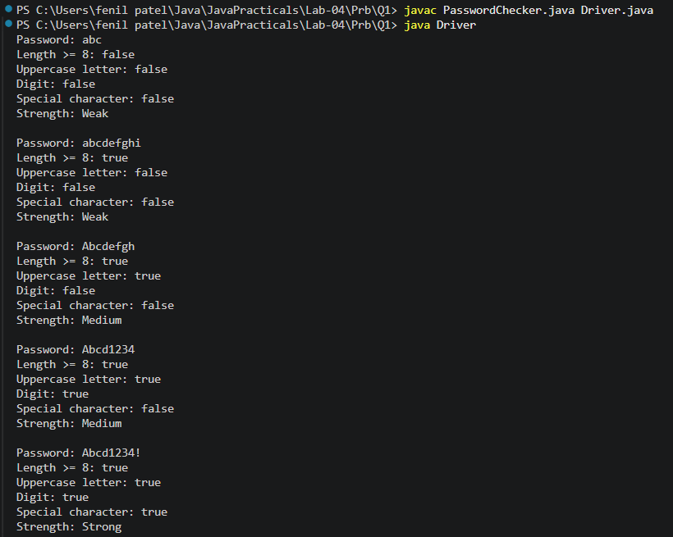
2) | AIM:Chat-log filter (ChatFilter.java + Driver.java)  - In Driver.main, define a String[] of log lines like “10:05 alice Hello there” (include one malformed line with fewer than 3 parts).  - Read a keyword from the user.  - For each line, split into time/user/message with split(“ ”, 3); skip lines that do not have 3 parts.  - If the message contains the keyword (case-insensitive), increment a counter and append “time user: message” to a StringBuilder.  - Print “Matches: N” and the built report.  Expected output: keyword “hello” over 3 lines (1 malformed) → “Matches: 1” and the matching line.
 | ChatFilter .java
Code | public class ChatFilter{  public static String filterLogs(String[] logs, String keyword){ int count=0;  StringBuilder report=new StringBuilder(); for(String line:logs){  String[] parts = line.split(" ",3); if (parts.length<3) {  continue;  }  String time = parts[0];

String user = parts[1]; String message = parts[2];
if(message.toLowerCase().contains(keyword.toLowerCase())){ count++;
report.append(time)
.append(" ")
.append(user)
.append(": ")
.append(message)
.append("\n");
}
}
return "Matches: " + count + "\n" + report;
}
}
 | Driver1.java
import java.util.Scanner;
public class Driver1{
public static void main(String[] args) { String[] logs = {
"10:05 alice Hello there", "10:06 bob How are you?", "10:07 InvalidLine"
};
Scanner sc = new Scanner(System.in); System.out.print("Enter keyword: "); String keyword = sc.nextLine();
String result = ChatFilter.filterLogs(logs, keyword); System.out.println(result);
sc.close();
}
}
Output
Q3) | AIM: Template filler (TemplateFiller.java + Driver.java)  - In Driver.main, define a template like “Dear {name}, order {id} ships {date}.” and two parallel arrays: names {“name”, “id”} and values {“Riya”, “A07”} (note {date}  is not supplied).  - Compile a Pattern for \{(\w+)\} and get a Matcher on the template.  - Walk the matches with a StringBuilder: for each {placeholder}, look up its value in the names array and replace with the value, or with “[?]” if not found.

(d) Print the filled template.
Expected output: the unsupplied {date} becomes [?].
 | TemplateFiller .java
Code | import java.util.regex.Matcher; import java.util.regex.Pattern; public class TemplateFiller{  public static String fillTemplate(String template, String[] names, String[] values){ Pattern pattern=Pattern.compile("\\{(\\w+)\\}");  Matcher matcher=pattern.matcher(template); StringBuilder result = new StringBuilder(); while (matcher.find()){  String placeholder = matcher.group(1); String replacement = "[?]";  for(int i=0;i<names.length;i++) { if(names[i].equals(placeholder)) {  replacement=values[i]; break;  }  }  matcher.appendReplacement(result, Matcher.quoteReplacement(replacement));  }  matcher.appendTail(result); return result.toString();  }  }
 | Driver2.java
Code | public class Driver2{  public static void main(String[] args){  String template = "Dear {name}, order {id} ships {date}."; String[] names = {"name", "id"};  String[] values = {"Riya", "A07"};  String result = TemplateFiller.fillTemplate( template, names, values);  System.out.println(result);  }  }
Output

